Activity No.
Title of the Event | Finance Club- FINQUEST | 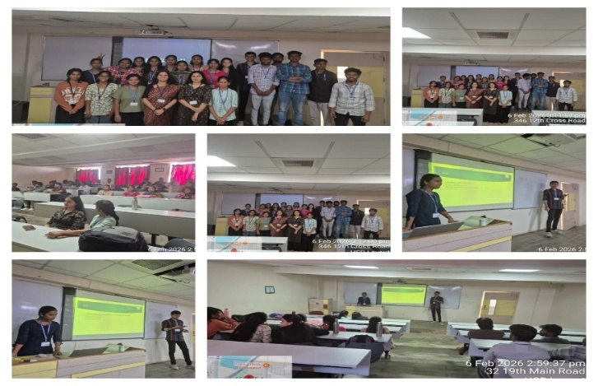
Day and Date | 6 February 2026
Venue (With all details) | Room No 309
In collaboration with (if any) | -
Details of Resource Person with Designation | Dr Priyanka Joshi  Assistant Professor | 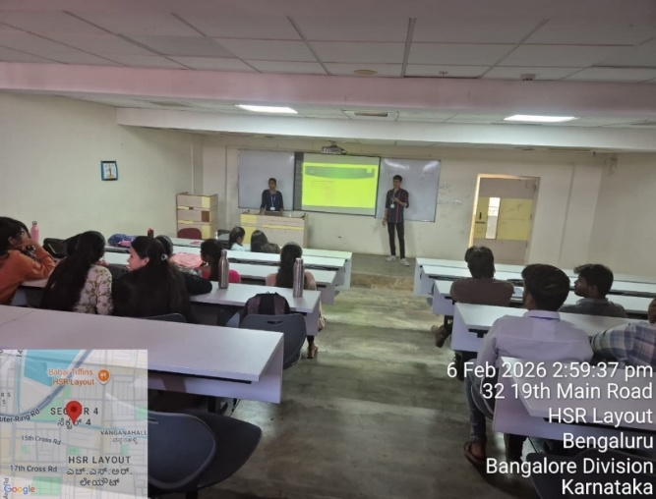
Organizing Department/Coordinators | Management Department  Finance Club  Dr Priyanka Joshi
Course and semester | MBA Semester 1
No of Students & Faculty Participants | 40 Students +1 Faculty

Coordinator HoD Vice-Principal Principal

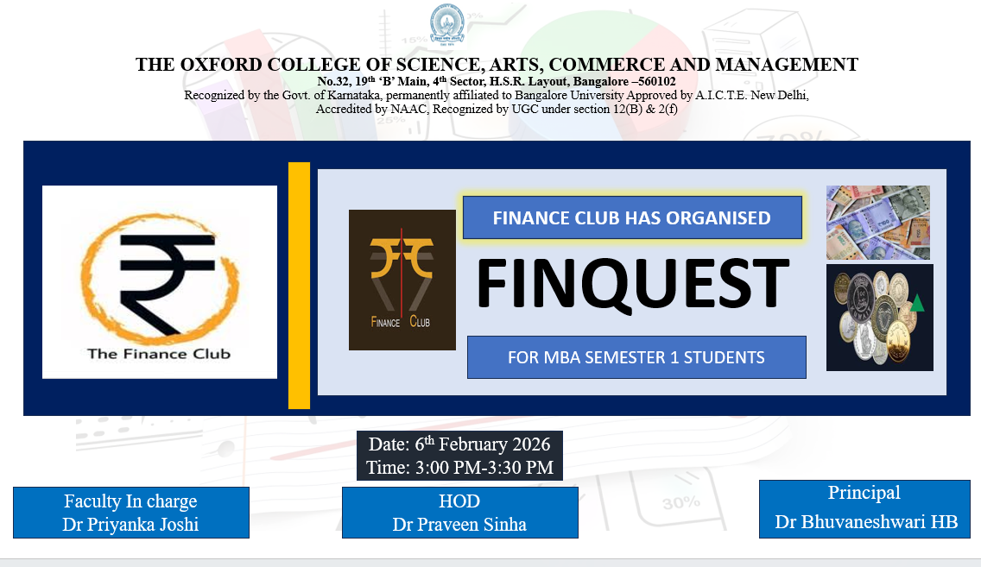
Introduction
The Finance Club organized an engaging and informative Quiz Activity with the objective of enhancing students’ knowledge of financial concepts and current economic trends. The quiz aimed to promote financial awareness, encourage analytical thinking, and create interest in the field of finance among MBA students.
Description of the Activity
The Finance Quiz was successfully organized for MBA Semester I students with enthusiastic participation from 40 students. The participants were divided into two teams—Team A and Team B—with each team comprising 18 members. The quiz created an engaging and competitive learning environment for all participants.
Outcome of the Activity
Both teams displayed sound knowledge of finance concepts and participated actively throughout the quiz. The event encouraged teamwork, quick thinking, and healthy competition among the students, making the session both informative and enjoyable.
Conclusion
Team B, represented by students Shubham and Monica, delivered a consistent and impressive performance during the quiz. Their efforts led Team B to emerge as the winner of the Finance Quiz, making the event a memorable and enriching academic experience for all participants.

